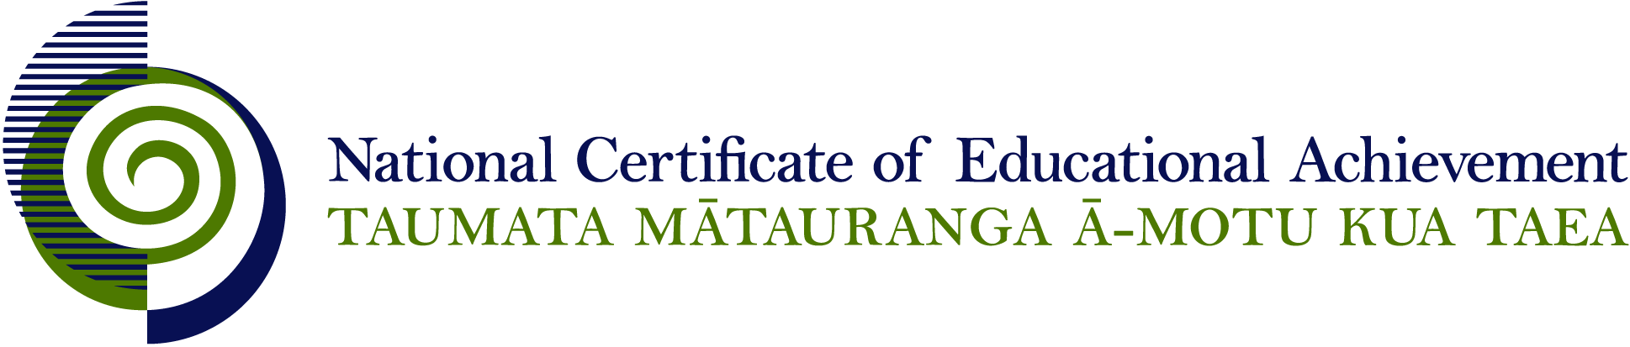

EXPIRED

NCEA Level 1 Art History

Conditions of Assessment

General Information

Subject Reference | Visual Arts
Domain | Art History
Level | 1

This document provides guidelines for assessment against internally assessed standards. Guidance is provided on:
- appropriate ways of, and conditions for, gathering evidence
- ensuring that evidence is authentic
- any other relevant advice specific to an achievement standard.

NB: It is expected that teachers are familiar with additional generic guidance on assessment practice in schools published on the NZQA website. This should be read in conjunction with these Conditions of Assessment.

For All Standards

Internal assessment provides considerable flexibility in the collection of evidence. Evidence can be collected in different ways to suit a range of teaching and learning styles and a range of contexts of teaching and learning. Care needs to be taken to allow students opportunities to present their best evidence against the standard(s) that are free from unnecessary constraints.

It is recommended that the design of assessment reflects and reinforces the ways students have been learning. Collection of evidence for the internally assessed standards could include, but is not restricted to, an extended task, an investigation, digital evidence (such as recorded interviews, blogs, photographs or film) or a portfolio of evidence.

It is also recommended that the collection of evidence for internally assessed standards should not use the same method that is used for any external standards in a programme/course, particularly if that method is using a time bound written examination. This could unfairly disadvantage students who do not perform well under these conditions.

A separate assessment event is not needed for each standard. Often assessment can be integrated into one activity that collects evidence towards two or three different standards from a programme of learning. Evidence can also be collected over time from a range of linked activities (for example, in a portfolio).This approach can also ease the assessment workload for both students and teachers.

Effective assessment should suit the nature of the learning being assessed, provide opportunities to meet the diverse needs of all students and be valid and fair.

Where manageable, and after further learning has taken place, students may be offered a maximum of one further opportunity for assessment against an assessment standard within a year.

Authenticity of student evidence needs to be assured regardless of the method of collecting evidence. This needs to be in line with school policy. For example, for an investigation carried out over several sessions, this could include teacher observations or the use of milestones such as meetings with students, journal or photographic entries recording progress etc.

Specific Information for Individual Internal Achievement Standards

Achievement Standard Number | 91016 Art History 1.2
Title | Demonstrate understanding of the subject matter of art works
Number of Credits | 4
Version | 2

Art works may be selected by the teacher or the student.

Art works may be selected:
- across varied art periods as a way to explore changes in subject matter in art history
- from the works of a specific artist
- from an art movement
- within a genre e.g. portraiture, landscape
- within a broad topic or theme e.g. ‘the land’, ‘cultural identity’.

The standard may be assessed through a written, oral, or visual response, or by a combination of these.

Where manageable, one further assessment opportunity may be made available for all students.

Achievement Standard Number | 91017 Art History 1.3
Title | Demonstrate understanding of links between context(s) and art works
Number of Credits | 4
Version | 3

Contexts and/or art works may be selected by the teacher or the student.

The standard may be assessed through a written, oral, or visual response, or by a combination of these.

Where manageable, one further assessment opportunity may be made available for all students.

Achievement Standard Number | 91018 Art History 1.4
Title | Demonstrate knowledge of media and methods used to produce art works
Number of Credits | 4
Version | 3

For this achievement standard candidates need to retain their focus on how media and methods are used to produce art works. Methods need not include preliminary drawings, pre-production planning, or preliminary preparation of materials.

Media and methods may be explored through practical tasks in this assessment. In this case the knowledge of media and methods is the assessable component. Artistic skills are not assessable.

The standard may be assessed through a written, oral, or visual response, or by a combination of these.

Where manageable, one further assessment opportunity may be made available for all students.

Achievement Standard Number | 91019 Art History 1.5
Title | Demonstrate understanding of developments in an artist’s work
Number of Credits | 4
Version | 2

The artist and art works may be selected by the teacher or the student.

The standard may be assessed through a written, oral, or visual response, or by a combination of these.

Where manageable, one further assessment opportunity may be made available for all students.

